

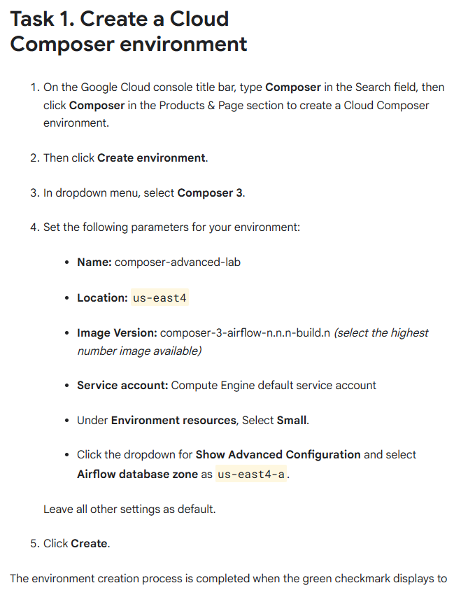

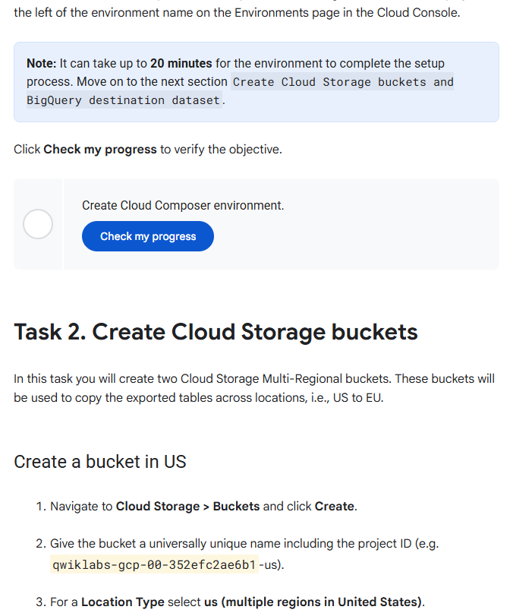

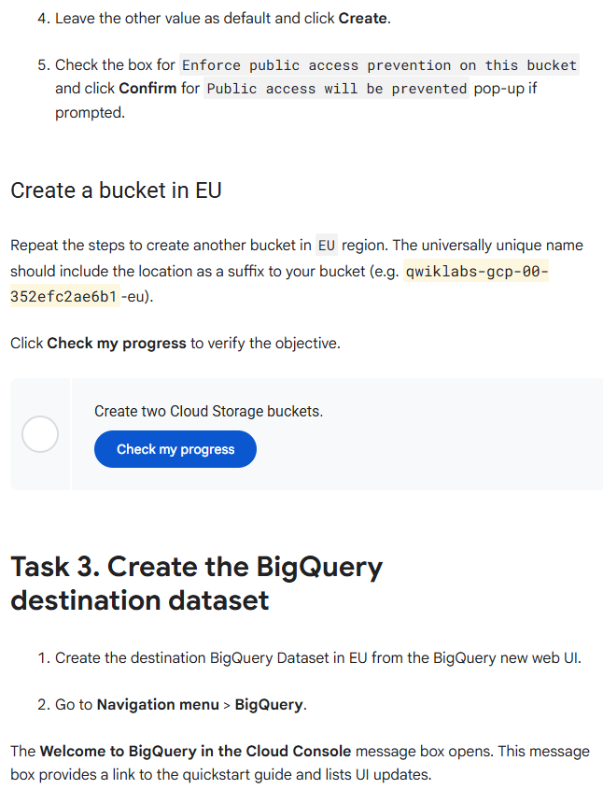

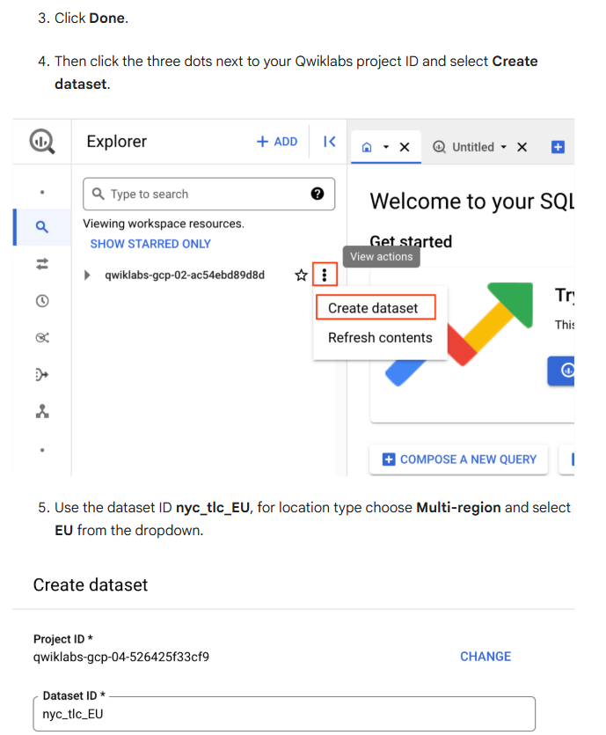

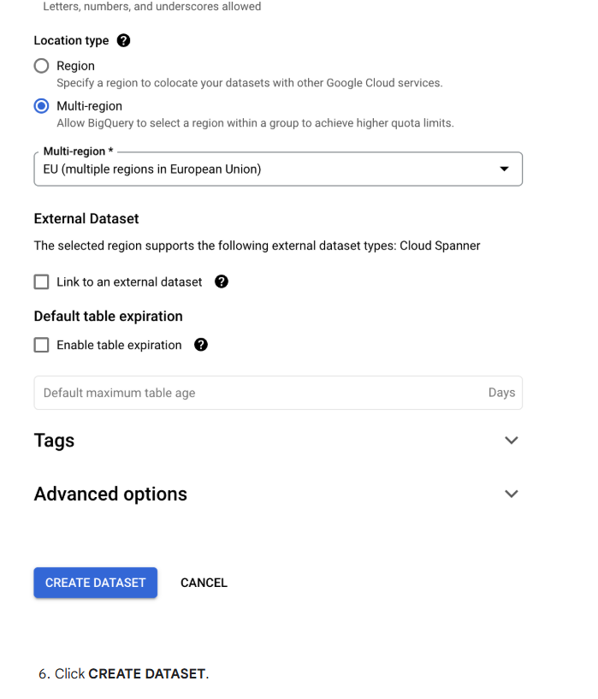

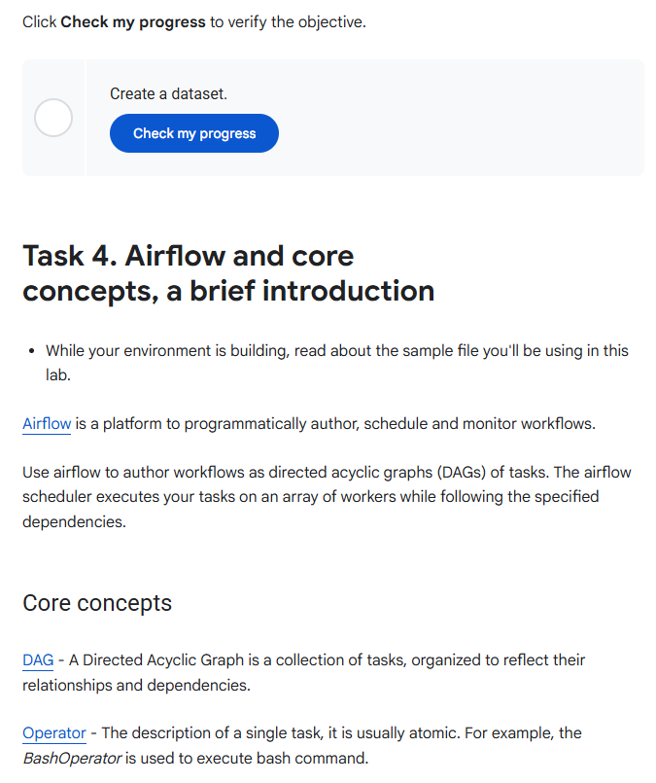

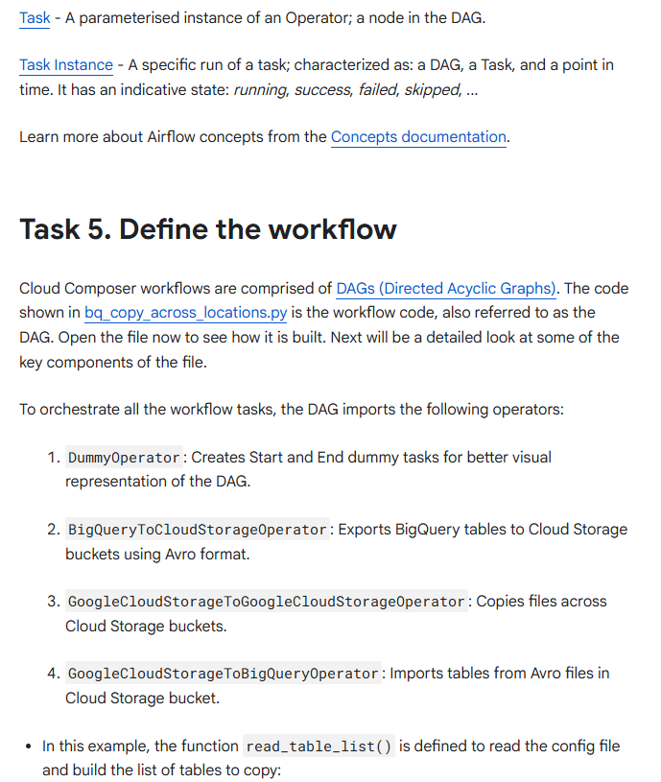

# --------------------------------------------------------------------------------

# Functions

# --------------------------------------------------------------------------------

def read_table_list(table_list_file):

"""

Reads the master CSV file that will help in creating Airflow tasks in

the DAG dynamically.

:param table_list_file: (String) The file location of the master file,

e.g. '/home/airflow/framework/master.csv'

:return master_record_all: (List) List of Python dictionaries containing

the information for a single row in master CSV file.

"""

master_record_all = []

logger.info('Reading table_list_file from : %s' % str(table_list_file))

try:

with open(table_list_file, 'rb') as csv_file:

csv_reader = csv.reader(csv_file)

next(csv_reader) # skip the headers

for row in csv_reader:

logger.info(row)

master_record = {

'table_source': row[0],

'table_dest': row[1]

}

master_record_all.append(master_record)

return master_record_all

except IOError as e:

logger.error('Error opening table_list_file %s: ' % str(

table_list_file), e)

* The name of the DAG is bq_copy_us_to_eu_01, and the DAG is not scheduled by default so needs to be triggered manually.

default_args = {

'owner': 'airflow',

'start_date': datetime.today(),

'depends_on_past': False,

'email': [''],

'email_on_failure': False,

'email_on_retry': False,

'retries': 1,

'retry_delay': timedelta(minutes=5),

}

# DAG object.

with models.DAG('bq_copy_us_to_eu_01',

default_args=default_args,

schedule_interval=None) as dag:

* To define the Cloud Storage plugin, the class Cloud StoragePlugin(AirflowPlugin) is defined, mapping the hook and operator downloaded from the Airflow 1.10-stable branch.

# Import operator from plugins

from gcs_plugin.operators import gcs_to_gcs

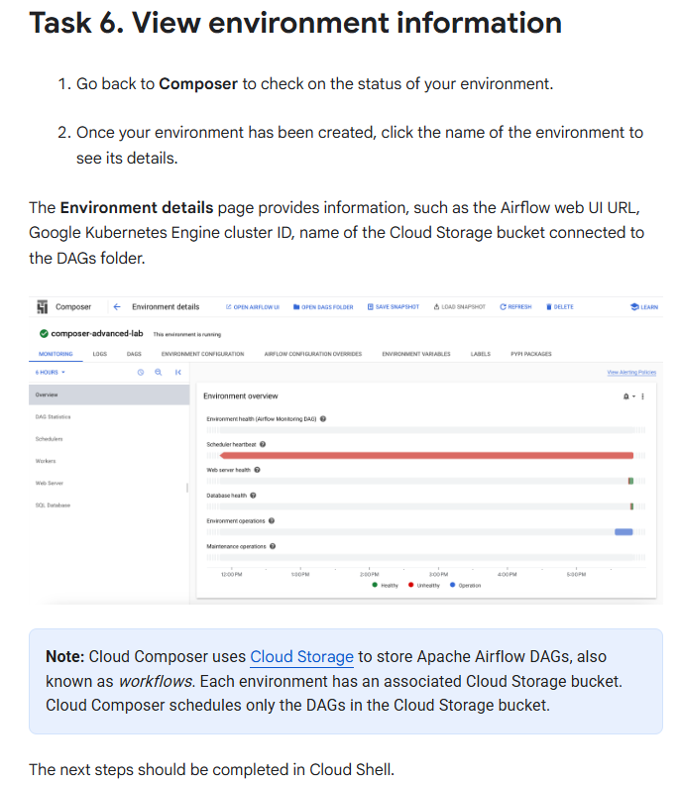

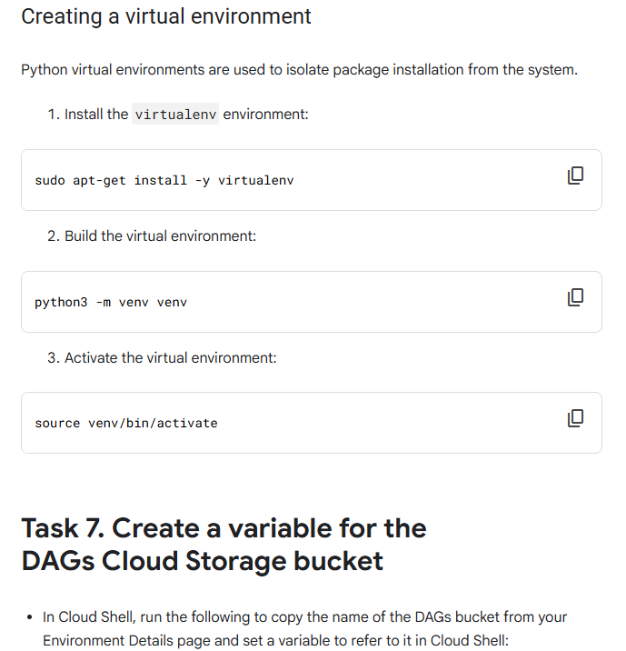

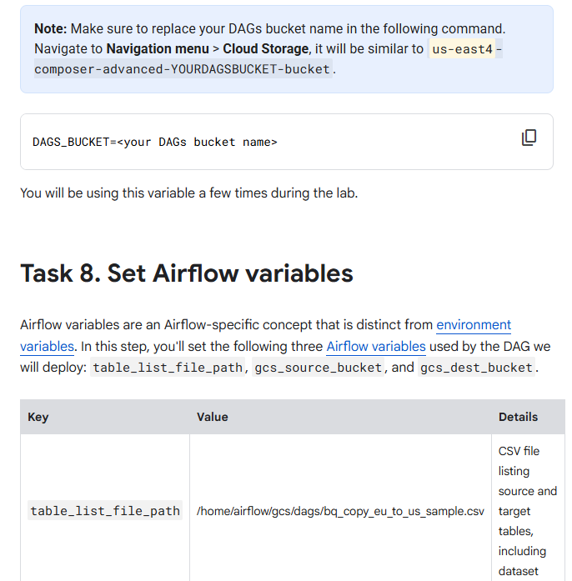

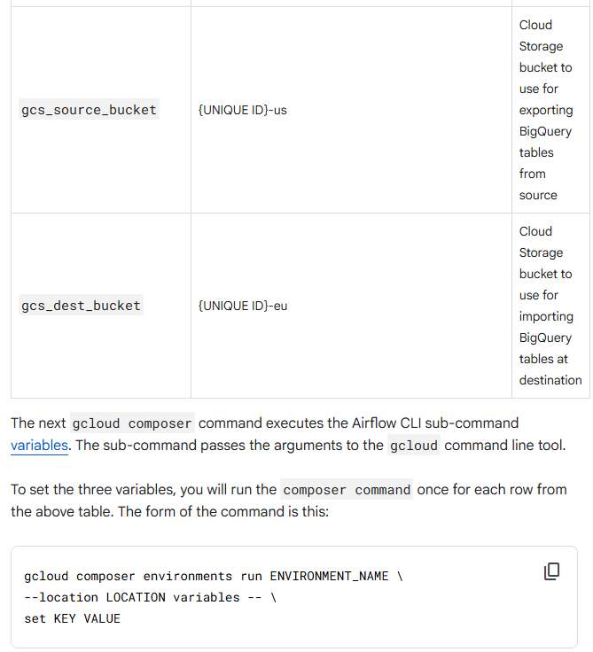

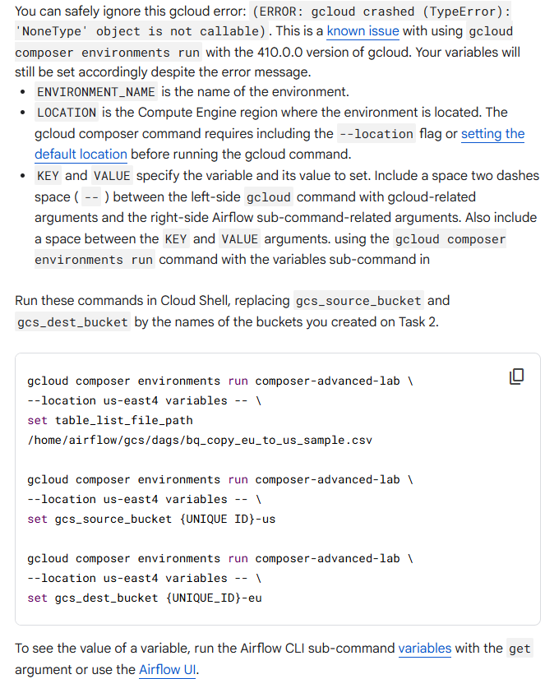

For example, run the following:

gcloud composer environments run composer-advanced-lab \

--location us-east4 variables -- \

get gcs_source_bucket

**Note**: Make sure to set all three Airflow variables used by the DAG.

